

**MENTAL HEALTH AND WELLBEING**

**POLICY**

**Adopted: July 2021**

**Last reviewed: September 2023**

**Designated Mental Health Lead: Danielle Stone**

**Links to other policies:** Safeguarding, Medical Needs, Anti-Bullying, SEND, School Behaviour Policy (behaviour that is disruptive, withdrawn, anxious, depressed or otherwise, may be related to an unmet mental health need), Staff Wellbeing

**CONTENTS**

**Policy Statement 3**

**Policy Scope 3**

**Policy Aims 3**

**Key Staff Members 4**

**What is Mental Health? 4**

**Risks and Protective Factors 5**

**Whole School Approach 7**

**Teaching About Mental Health 7**

**Support at School and in the Local Community 8**

**Training 8**

**Policy Review 8**

**Appendices**

* **JIGSAW PSHE curriculum overview 9**
* **Signposts to further information 16**

**POLICY STATEMENT**

At North West London Jewish Day School (NWLJDS), we are committed to supporting the mental health and wellbeing of our pupils and staff.

Our culture is supportive, caring and respectful. We encourage pupils to be open and we want each child to have their voice heard. We adopt a whole school approach where positive mental health is everybody’s responsibility.

**POLICY SCOPE**

This policy is a guide to all staff, including teachers, governors and non-teaching staff. It outlines our approach to promoting pupil mental health and wellbeing. It should be read and understood alongside our other relevant school policies.

**POLICY AIMS**

The aim of our policy is to demonstrate our commitment to the mental health of our staff and pupils.

**At NWLJDS, we will always:**

* Help children to understand their emotions and experiences better
* Ensure our pupils feel comfortable sharing any concerns and worries
* Help children to form and maintain relationships
* Encourage children to be confident and help to promote their self esteem
* Help children to develop resilience and ways of coping with setbacks
* Ensure a curriculum is taught from Nursery to Year 6 where pupils explicitly learn about managing emotions and how to stay healthy (physically, mentally and emotionally) and how to seek help if necessary.

**We will always promote a healthy environment by:**

* Promoting positive mental health and emotional wellbeing in all pupils and staff
* Celebrating both academic and non-academic achievements
* Promoting our school values and encouraging a sense of belonging and community
* Providing opportunities to develop a sense of worth and the ability to reflect
* Celebrating each pupil for who they are and making every pupil feel valued and respected
* Adopting a whole school approach to mental health and providing support to any pupil that needs it
* Raising awareness amongst staff and pupils about mental health issues and their signs and symptoms
* Training and supporting all staff to understand mental health issues and spot early warning signs to help prevent or address mental health problems
* Supporting staff who are struggling with their own mental health

**KEY STAFF MEMBERS**

All staff members have a responsibility to promote the mental health of pupils and each other. All class teachers are expected to establish positive relationships with every child. However, certain staff members have specific role in the process.

These are:

**Designated Child Protection Officers:** Judith Caplan, Amanda Shoota, Madeleine Bendell

**Designated Mental Health Lead:** Danielle Stone

**WHAT IS MENTAL HEALTH?**

Mental health affects how a person feels, thinks and acts. It refers to a person’s emotional, psychological, and social wellbeing. An individual’s mental health can change and fluctuate on a daily basis and over time, and can be affected by a range of factors.

When children have good levels of wellbeing it helps them to:

* + Learn and explore the world
  + Feel, express and manage positive and negative emotions
  + Form and maintain good relationships with others
  + Cope with, and manage, change, setbacks and uncertainty
  + Develop and thrive

When children look after their mental health and develop their coping skills, it can help them to boost their resilience, self-esteem and confidence. It can also help them learn to settle themselves, feel calm, and engage positively with their education – which can, in turn, improve their academic attainment.

*The mental health spectrum*

At any one time, a child or young person may be anywhere on a spectrum between being healthy and unwell. Many children move along the spectrum at different times.

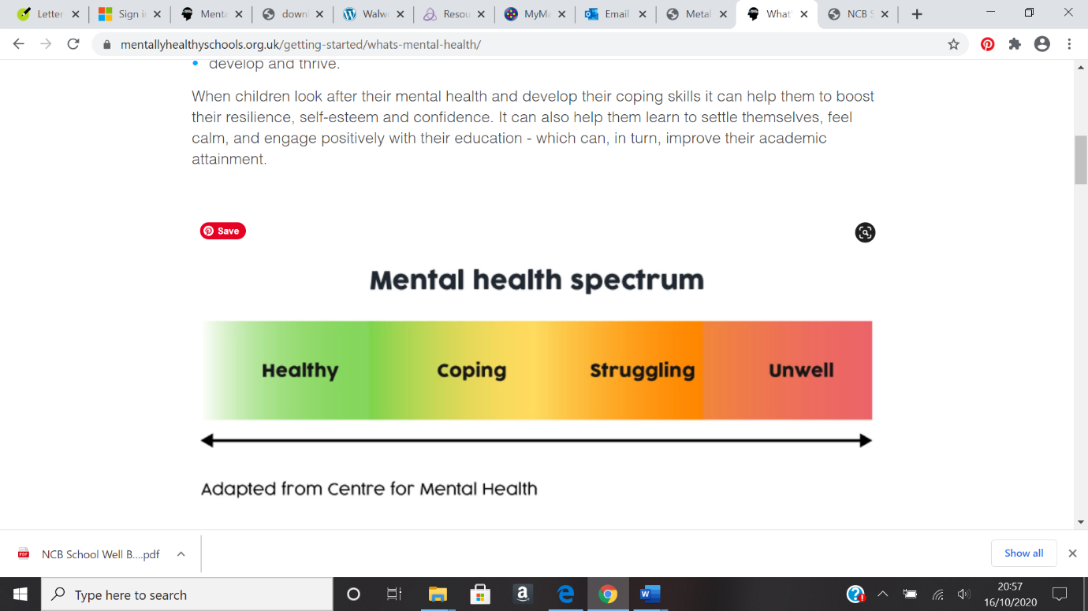

*What affects a child’s mental health?*

A child’s mental health will be influenced by many things over time, and because children have different personalities, they will react and cope with challenging situations in different ways.

The presence or absence and various combinations of protective and risk factors contribute to the mental health of children. Risk factors may challenge and undermine children’s mental health whereas protective factors are measures that schools can put in place that help build good mental health and resilience, and reduce the risks that can harm children’s mental health.

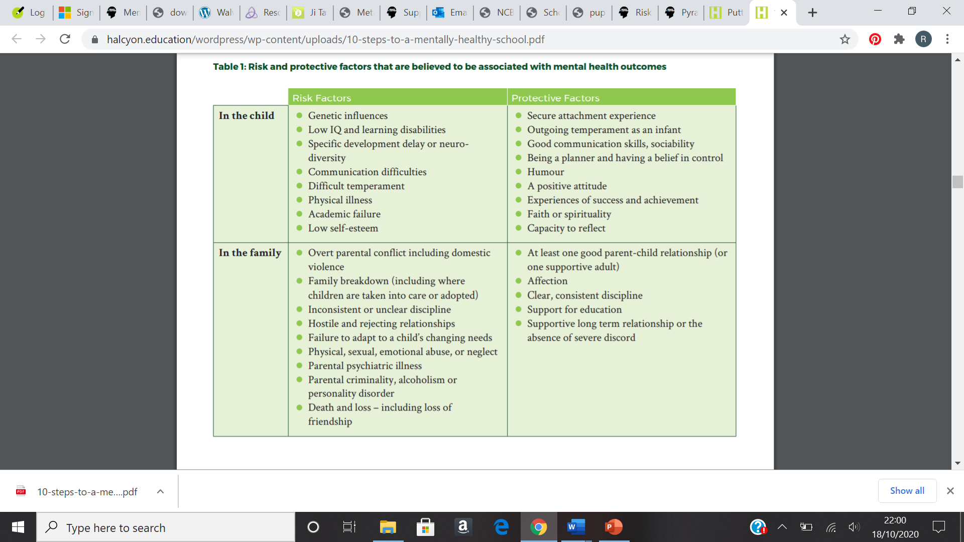FROM DFE ‘MENTAL HEALTH AND BEHAVIOUR IN SCHOOLS’ NOVEMBER 2018

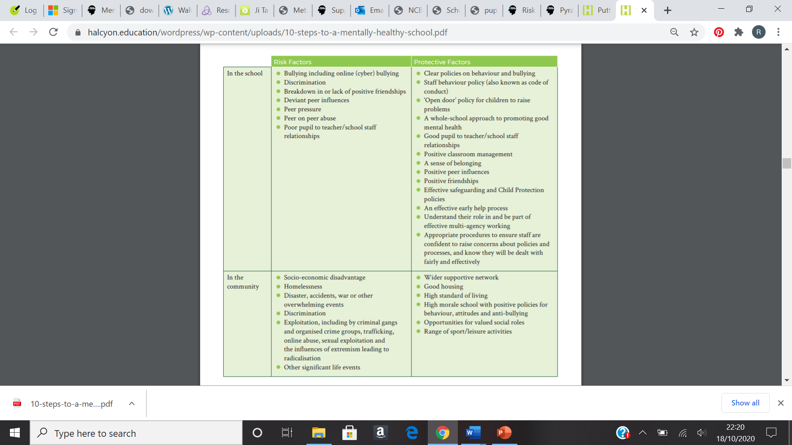Research for England suggests that one in 10 primary school children aged five to 10 has an identifiable mental health condition. Factors that can put a child more at risk of developing mental health problems can be identified early, otherwise there is a greater chance of them developing a mental health problem.

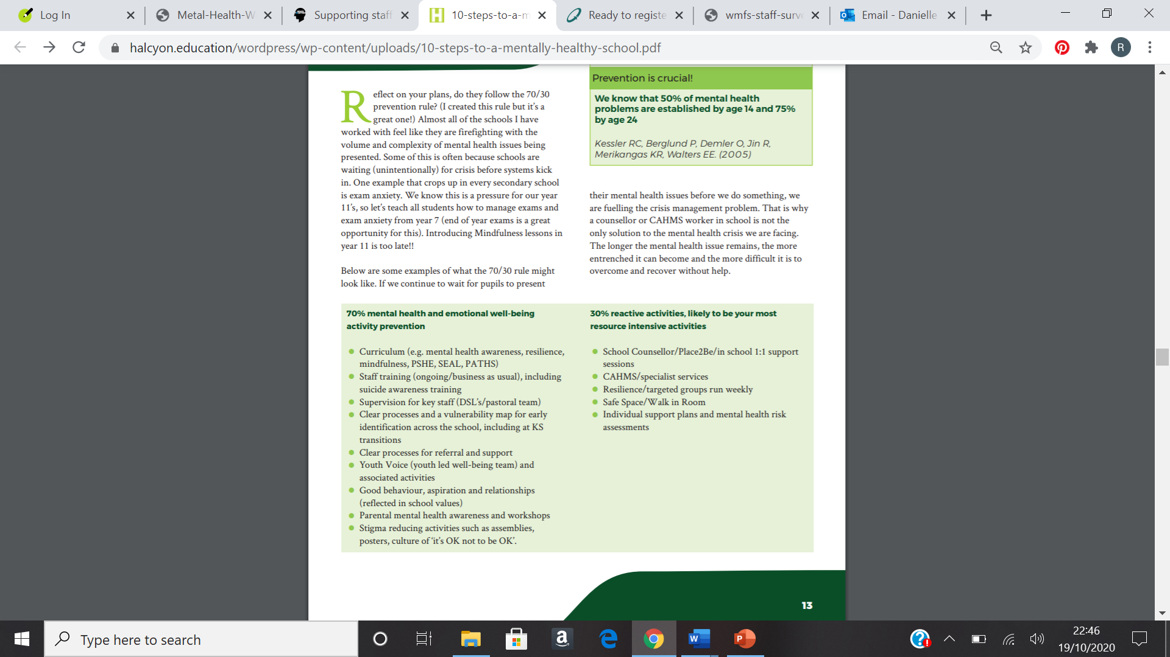**We believe *preventative measures* and *early action* is the best thing we can do as a school to help give our pupils the best start in life.**

**WHOLE SCHOOL APPROACH**

We take a whole school approach to becoming a mentally healthy school. A whole-school approach involves all parts of the school working together and being committed. It needs partnership working between senior leaders, governors, teachers and all school staff, as well as parents, carers and the wider community.

This encompasses five aspects:

1. Develop a **supportive school and classroom climate** which builds a sense of connectedness, focus and purpose, the acceptance of emotion and vulnerability. It should also foster warm relationships and the celebration of difference.
2. **Engagement of the whole community** – encouraging pupil voice whilst engaging parents and families. Parents should feel supported as much as possible and always be kept informed about their child. Ensure parents are aware of who to talk to if they have concerns about their child and give guidance about how they can support their child’s/children’s positive mental health
3. Prioritise **continuous professional learning and staff development** that makes it clear that promoting good mental health is the responsibility of all members of school staff and community.
4. Implement **targeted programmes and interventions** and explicitly teach social and emotional skills.
5. Implement targeted responses and identify specialist pathways including the involvement of **outside agencies**, (e.g. paediatricians, CAMHS, counselling services, therapists, family support workers).

**TEACHING ABOUT MENTAL HEALTH**

At NWLJDS we aim to help children develop social and emotional skills providing them with the coping skills and tools they need to understand and manage their thoughts, feelings, behaviour, goals and relationships; as well as thrive, be self-aware, have confidence and be able to work in a team.

Good evidence shows that school programmes which promote social and emotional skills can improve children’s mental health and academic attainment. Children with good mental health are more positive, engaged in school and can achieve better academically.

At NWLJDS, pupils are taught explicit health and wellbeing lessons via the **Jigsaw PSHE curriculum** (see appendix for full curriculum overview), and attempts are made to weave these topics and skills throughout the broader curriculum and school life. [Primary and Secondary PSHE fulfilling RSE | Jigsaw PSHE Ltd](https://www.jigsawpshe.com/)

**SUPPORT AT SCHOOL AND IN THE LOCAL COMMUNITY**

Teachers are encouraged to disclose any concerns regarding pupils’ mental and emotional health to the safeguarding team/mental health lead. If a child’s behaviour is deemed as high risk, or if a changed behaviour continues, then they are encouraged to make a referral to the following support systems available in school:

* ELSA (Emotional Literacy Support Assistants): Danielle Stone, Adina Elkouby
* Lego Therapy (training and resources from BOAT)
* Social Skills group (training and resources from Brent SLT)
* Art/Play Psychotherapy: Hester Ford/Dalia Tricot (referrals made to Danielle Stone)
* Talking Therapy: Janine Tamman, children’s psychotherapist (referrals made to Danielle Stone)

There are also support networks available in the local community, that are accessible via referrals made by the ECM team. This includes:

* Child and Adolescent Mental Health Services (CAMHS)
* Wellbeing and Emotional Support Team (WEST) for pupils living in Brent
* Barnet Intergrated Children’s Services (BICS) for pupils living in Barnet
* Chai Cancer Care
* Grief Encounters

**TRAINING**

As a minimum, all staff will receive termly training about recognising and responding to mental health issues. All staff received training from JIGSAW PSHE, and further training can be organised for specific topics if necessary.

We will host relevant information on the school website for staff (and parents) who wish to learn more about mental health. It should inform staff about the early signs of mental health problems, what is and is not a cause for concern, and what to do if they think they have spotted a developing problem.

The following online training is available to all staff

* **The MindEd** ([www.minded.org.uk](http://www.minded.org.uk)) learning portal provides free online training suitable for staff wishing to know more about a specific issue.
* **The National College** – currently have whole school access to a range of courses and webinars with ‘mental health’ as a main topic. All staff have completed the “Certificate in Understanding Mental Health”
* **Mental Health Champions** (Place2be/Pajes) – a short course of 5 modules. A member of staff from each cohort have completed the training.

POLICY REVIEW

This policy will be reviewed every year. This is so it remains up to date, useful, and relevant.

We will also regularly review it in accordance with local and national policy changes.

*It is also important to note that NWLJDS achieved The Wellbeing Award for Schools via Optimus Education 2023-2026.

APPENDICES

Information from NHS England tells us that 1 in 8 five to 19-year olds had at least one ‘mental disorder’ when assessed in 2017. Among primary school children, one in 10 five to 10-year olds had a mental disorder, with boys about twice as likely to be experiencing a mental disorder than girls.

NHS England splits these disorders into four broad categories:

* Emotional
* Behavioural
* Hyperactivity
* Other less common disorders

Emotional disorders were the most prevalent type of disorder experience by five to 19-year olds. Emotional disorders include:

* Anxiety disorders (characterised by fear and worry)
* Depressive disorders (characterised by sadness, loss of interest and energy, and low self-esteem
* Mania and bipolar affective disorder

JIGSAW CURRICULUM – SOCIAL/EMOTIONAL

Mental Health in JIGSAW PSHE

|  |  |
| --- | --- |
| * H1 that mental wellbeing is a normal part of daily life, in the same way as physical health. * H2 that there is a normal range of emotions (e.g. happiness, sadness, anger, fear, surprise, nervousness) and scale of emotions that all humans experience in relation to different experiences and situations. * H3 how to recognise and talk about their emotions, including having a varied vocabulary of words to use when talking about their own and others’ feelings. * H4 how to judge whether what they are feeling and how they are behaving is appropriate and proportionate. * H5 the benefits of physical exercise, time outdoors, community participation, voluntary and service-based activity on mental well-being and happiness. * H6 simple self-care techniques, including the importance of rest, time spent with friends and family and the benefits of hobbies and interests. * H7 isolation and loneliness can affect children and that it is very important for children to discuss their feelings with an adult and seek support. * H8 that bullying (including cyberbullying) has a negative and often lasting impact on mental well-being. * H9 where and how to seek support (including recognising the triggers for seeking support), including whom in school they should speak to if they are worried about their own or someone else’s mental well-being or ability to control their emotions (including issues arising online). * H10 it is common for people to experience mental ill health. For many people who do, the problems can be resolved if the right support is made available, especially if accessed early enough. | All of these aspects are covered in lessons within the Puzzles   * Healthy Me * Relationships * Changing Me * Celebrating Difference |

Social and Emotional Skills in JIGSAW PSHE

(Each Jigsaw Piece is a unit of work spanning over half a term. Each year group completes the same unit at the same time. This table shows the progression of skills taught from Nursery through to Year 6)

|  |  |  |
| --- | --- | --- |
| Jigsaw Piece | Year Group | Social and Emotional Skills |
| Being Me | EYFS | * + Identify feelings associated with belonging   + Identify feelings of happiness and sadness   + Skills to play cooperatively with others   + Be able to consider others’ feelings   + Be responsible in the setting |
|  | Year 1 | * + Understanding that they are special   + Understand that they are safe in their class   + Identifying helpful behaviours to make the class a safe place   + Identify what its like to feel proud of an achievement   + Recognise feelings associated with positive and negative consequences   + Understand that they have choices |
|  | Year 2 | * + Recognise own feelings and know when and where to get help   + Know how to make their class a safe and fair place   + Show good listening skills   + Recognise the feeling of being worried   + Be able to work cooperatively |
|  | Year 3 | * + Recognise self-worth   + Identify personal strengths   + Be able to set a personal goal   + Recognise feelings of happiness, sadness, worry and fear in themselves in others   + Make other people feel valued   + Develop compassion and empathy for others   + Be able to work collaboratively |
|  | Year 4 | * + Identify the feelings associated with being included or excluded   + Can make others feel valued and included   + Be able to take on a role in a group discussion/task and contribute to the overall outcome   + Can make others feel cared for and welcomed   + Recognise the feelings of being motivated or unmotivated   + Be able to help friends make positive choices   + Know how to regulate my emotions |
|  | Year 5 | * + Be able to identify what they value most about school   + Identify hopes for the school year   + Empathy for people whose lives are different from their own   + Consider their own actions and the effect they have on themselves and others   + Be able to work as part of a group, listening and contributing effectively   + Be able to help friends make positive choices   + Know how to regulate my emotions |
|  | Year 6 | * + Be able to make others feel welcomed and valued   + Know own wants and needs   + Be able to compare their life with the lives of those less fortunate   + Demonstrate empathy and understanding towards others   + Can demonstrate attributes of a positive role-model   + Can take positive action to help others   + Be able to contribute towards a group task   + Know what effective group work is   + Know how to regulate my emotions |

|  |  |  |
| --- | --- | --- |
| Jigsaw Piece | Age | Social and Emotional Skills |
| Celebrating differences | EYFS | * + Identify feelings associated with being proud   + Identify things they are good at   + Be able to vocalise success for themselves and about other successes   + Identify some ways they can be different and the same as others   + Recognise similarities and differences between their family and other families   + Identify and use skills to make a friend   + Identify and use skills to stand up for themselves   + Recognise emotions when they or someone is upset, frightened or angry |
|  | Year 1 | * + Recognise ways in which they are the same as their friends and ways they are different   + Identify what is bullying and what isn’t   + Understand how being bullied might feel   + Know ways to help a person who is being bullied   + Identify emotions associated with making a new friend   + Verbalise some of the attributes that make them unique and special |
|  | Year 2 | * + Understand that boys and girls can be similar in lots of ways and that is okay   + Understand that boys and girls can be different in lots of ways and that is okay   + Explain how being bullied can make someone feel   + Can choose to be kind to someone who is being bullied   + Know how to stand up for themselves when they need to   + Recognise that they shouldn’t judge people because they are different   + Understand that everyone’s differences make them special and unique |
|  | Year 3 | * + Be able to show appreciation for their families, parents and carers   + Use the “Solve it together” technique to calm and resolve conflicts with friends and family   + Empathise with people being bullied   + Employ skills to support someone who is bullied   + Be able to “problem-solve” a bullying situation accessing appropriate support if necessary   + Be able to recognise, accept and give compliments   + Recognise feelings associated with receiving a compliment |
|  | Year 4 | * + Try to accept people for who they are   + Identify influences that have made them think or feel positively/negatively about a situation   + Identify reasons why a bystander might join in with bullying   + Revisit the “solve it together” technique to practise conflict and bullying scenarios   + Identify their own uniqueness   + Be comfortable with the way they look   + Identify when a first impression they had was right or wrong   + Be non-judgemental about others who are different |
|  | Year 5 | * + Identify their own culture and different cultures within their class community   + Identify their own attitudes about people from different faith and cultural backgrounds   + Identify a range of strategies for managing their own feelings in bullying situations   + Identify some strategies to encourage children who use bullying behaviours to make other choices   + Be able to support children who are being bullied   + Appreciate the value of happiness regardless of material wealth   + Develop respect for cultures different from their own |
|  | Year 6 | * + Empathise with people who are different and be aware of my own feelings towards him   + Identify feelings associated with being excluded   + Be able to recognise when someone is exerting power negatively in a relationship   + Use a range of strategies when involved in a bullying situation or in situations where different is a source of conflict   + Identify different feelings of the bully, bullied and bystanders in a bullying scenario   + Be able to vocalise their thoughts and feelings about prejudice and discrimination and why it happens   + Appreciate people for who they are   + Show empathy |

|  |  |  |
| --- | --- | --- |
| Jigsaw Piece | Age | Social and Emotional Skills |
| Dreams and Goals | EYFS | * + Understand that challenges can be difficult   + Recognise some of the feelings linked to perseverance   + Talk about a time that they kept on trying and achieved a goal   + Be ambitious   + Resilience   + Recognise how kind words can encourage people • Feel proud • Celebrate success |
|  | Year 1 | * + Recognise things that they do well   + Explain how they learn best   + Celebrate an achievement with a friend   + Recognise their own feelings when faced with a challenge   + Recognise their own feelings when they are faced with an obstacle   + Recognise how they feel when they overcome an obstacle   + Can store feelings of success so that they can be used in the future |
|  | Year 2 | * + Be able to describe their own achievements and the feelings linked to this   + Recognise their own strengths as a learner   + Recognise how working with others can be helpful   + Be able to work effectively with a partner   + Be able to choose a partner with whom they work well   + Be able to work as part of a group   + Recognise how it feels to be part of a group that succeeds and store this feeling |
|  | Year 3 | * + Recognise other people’s achievements in overcoming difficulties   + Imagine how it will feel when they achieve their dream / ambition   + Can break down a goal into small steps   + Recognise how other people can help them to achieve their goals   + Can manage feelings of frustration linked to facing obstacles   + Can share their success with others   + Can store feelings of success (in their internal treasure chest) to be used at another time |
|  | Year 4 | * + Can talk about their hopes and dreams and the feelings associated with these   + Can identify the feeling of disappointment   + Can identify a time when they have felt disappointed   + Be able to cope with disappointment   + Help others to cope with disappointment   + Can identify what resilience is   + Have a positive attitude   + Enjoy being part of a group challenge   + Can share their success with others   + Can store feelings of success (in their internal treasure chest) to be used at another time |
|  | Year 5 | * + Verbalise what they would like their life to be like when they are grown up   + Appreciate the contributions made by people in different jobs   + Appreciate the opportunities learning and education can give them   + Reflect on the differences between their own learning goals and those of someone from a different culture   + Appreciate the differences between themselves and someone from a different culture   + Understand why they are motivated to make a positive contribution to supporting others |
|  | Year 6 | * + Understand why it is important to stretch the boundaries of their current learning   + Set success criteria so that they know when they have achieved their goal   + Recognise the emotions they experience when they consider people in the world who are suffering or living in difficult circumstances   + Empathise with people who are suffering or living in difficult situations   + Be able to give praise and compliments to other people when they recognise that person’s achievements |

|  |  |  |
| --- | --- | --- |
| Jigsaw Piece | Age | Social and Emotional Skills |
| Healthy Me | EYFS | * + Recognise how exercise makes them feel   + Recognise how different foods can make them feel   + Can explain what they need to do to stay healthy   + Can give examples of healthy food   + Can explain how they might feel if they don’t get enough sleep   + Can explain what to do if a stranger approaches them |
|  | Year 1 | * + Feel good about themselves when they make healthy choices   + Realise that they are special   + Keep themselves safe   + Recognise ways to look after themselves if they feel poorly   + Recognise when they feel frightened and know how to ask for help   + Recognise how being healthy helps them to feel happy |
|  | Year 2 | * + Desire to make healthy choices   + Identify when a feeling is weak and when a feeling is strong   + Feel positive about caring for their bodies and keeping it healthy   + Have a healthy relationship with food   + Express how it feels to share healthy food with their friends |
|  | Year 3 | * + Able to set themselves a fitness challenge   + Recognise what it feels like to make a healthy choice   + Identify how they feel about drugs   + Can express how being anxious or scared feels   + Can take responsibility for keeping themselves and others safe   + Respect their own bodies and appreciate what they do |
|  | Year 4 | * + Can identify the feelings that they have about their friends and different friendship groups   + Recognise how different people and groups thy interact with impact on them   + Identify which people they most want to be friends with   + Recognise negative feelings of anxiety and fear associated with pressure   + Can tap into their inner strength and know-how to be assertive |
|  | Year 5 | * + Can make informed decisions about whether or not they choose to smoke when they are older   + Can make informed decisions about whether they choose to drink alcohol when they are older   + Recognise strategies for resisting pressure   + Can identify ways to keep themselves calm in an emergency   + Can reflect on their own body image and know how important it is that this is positive   + Accept and respect themselves for who they are   + Respect and value their own bodies   + Be motivated to keep themselves healthy and happy |
|  | Year 6 | * + Are motivated to care for their own physical and emotional health   + Are motivated to find ways to be happy and cope with life’s situations without using drugs   + Identify ways that someone who is being exploited could help themselves   + Suggest strategies someone could use to avoid being pressured   + Recognise that people have different attitudes towards mental health/illness   + Can use different strategies to manage stress and pressure |

|  |  |  |
| --- | --- | --- |
| Jigsaw Piece | Age | Social and Emotional Skills |
| Relationships | EYFS | * + Can identify what jobs they do in their family and those carried out by parents/carers and siblings   + Can suggest ways to make a friend or help someone who is lonely   + Can use different ways to mend a friendship   + Can recognise what being angry feels like   + Can use Calm Me time when angry or upset |
|  | Year 1 | * + Can express how it feels to be part of a family and to care for family members   + Can say what being a good friend means   + Can show skills of friendship   + Can identify forms of physical contact they prefer   + Can say no when they receive a touch they don’t like   + Can praise themselves and others   + Can recognise some of their personal qualities   + Can say why they appreciate a special relationship |
|  | Year 2 | * + Can identify the different roles and responsibilities in their family   + Can recognise the value that families can bring   + Can recognise and talk about the types of physical contact that is acceptable or unacceptable   + Can use positive problem-solving techniques to resolve a friendship conflict   + Can identify the negative feelings associated with keeping a worry secret   + Can identify the feelings associated with trust   + Can identify who they trust in their own relationships   + Can give and receive compliments   + Can say who they would go to for help if they worried or scared |
|  | Year 3 | * + Can identify the responsibilities they have within their family   + Can use solve-it-together in a conflict scenario and find a win-win outcome   + Know how to access help if they are concerned about anything on social media or the internet   + Can empathise with people from other countries who may not have a fair job/less fortunate   + Understand that they are connected to the global community in many different ways   + Can identify similarities in children’s rights around the world   + Can identify their own wants and needs and how these may be similar or different from other children in school and the global community |
|  | Year 4 | * + Can identify feelings and emotions that accompany jealousy   + Can suggest positive strategies for managing jealousy   + Can identify people who are special to them and express why   + Can identify the feelings and emotions that accompany loss   + Can suggest strategies for managing loss   + Can tell you about someone they no longer see   + Can suggest ways to manage relationship changes including how to negotiate |
|  | Year 5 | * + Can suggest strategies for building self-esteem of themselves and others   + Can identify when an online community/social media group feels risky, uncomfortable, or unsafe   + Can suggest strategies for staying safe online/social media   + Can say how to report unsafe online/social network activity   + Can identify when an online game is safe or unsafe   + Can suggest ways to monitor and reduce screen time   + Can suggest strategies for managing unhelpful pressures online or in social networks |
|  | Year 6 | * + Recognise that people can get problems with their mental health and that it is nothing to be ashamed of   + Can help themselves and others when worried about a mental health problem   + Recognise when they are feeling grief and have strategies to manage them   + Demonstrate ways they could stand up for themselves and their friends in situation where others are trying to gain power or control   + Can resist pressure to do something online that might hurt themselves or others   + Can take responsibility for their own safety and well-being |

|  |  |  |
| --- | --- | --- |
| Jigsaw Piece | Age | Social and Emotional Skills |
| Changing Me | EYFS | * + Can identify how they have changed from a baby   + Can say what might change for them when they get older   + Recognise that changing class can illicit happy and/or sad emotions   + Can say how they feel about changing class/growing up   + Can identify positive memories from the past year in school/home |
|  | Year 1 | * + Understand and accepts that change is a natural part of getting older   + Can identify some things that have changed and some things that have stayed the same since being a baby (including the body)   + Can express why they enjoy learning   + Can suggest ways to manage change e.g. moving to a new class |
|  | Year 2 | * + Can appreciate that changes will happen and that some can be controlled and others not   + Be able to express how they feel about changes   + Show appreciation for people who are older   + Can recognise the independence and responsibilities they have now compared to being a baby or toddler   + Can say what greater responsibilities and freedoms they may have in the future   + Can say who they would go to for help if worried or scared   + Can say what types of touch they find comfortable/uncomfortable   + Be able to confidently ask someone to stop if they are being hurt or frightened   + Can say what they are looking forward to in the next year |
|  | Year 3 | * + Can express how they feel about babies   + Can describe the emotions that a new baby can bring to a family   + Can express how they feel about puberty   + Can say who they can talk to about puberty if they have any worries   + Can identify stereotypical family roles and challenge these ideas, e.g. it may not always be Mum who does the laundry   + Can identify changes they are looking forward to in the next year   + Can suggest ways to help them manage feelings during changes they are more anxious about |
|  | Year 4 | * + Can appreciate their own uniqueness and that of others   + Can express how they feel about having children when they grow up   + Can express any concerns they have about puberty   + Can say who they can talk to about puberty if they are worried   + Can apply the circle of change model to themselves to have strategies for managing change   + Have strategies for managing the emotions relating to change |
|  | Year 5 | * + Can celebrate what they like about their own and thers’ self-image and body-image   + Can suggest ways to boost self-esteem of self and others   + Recognise that puberty is a natural process that happens to everybody and that it will be okay for them   + Can ask questions about puberty to seek clarification   + Can express how they feel about having a romantic relationship when they are an adult   + Can express how they feel about having children when they are an adult   + Can express how they feel about becoming a teenager   + Can say who they can talk to if concerned about puberty or becoming a teenager/adult |
|  | Year 6 | * + Recognise ways that can develop their own self-esteem   + Can express how they feel about the changes that will happen to them during puberty   + Recognise how they feel when they reflect on the development and birth of a baby   + Understand that mutual respect is essential in a boyfriend/girlfriend relationship and that they shouldn’t feel pressured into doing something that they don’t want to   + Can celebrate what they like about their own and others’ self-image and body-image   + Use strategies to prepare themselves emotionally for the transition (changes) to secondary school |

Signpost to further information

|  |  |  |
| --- | --- | --- |
|  | Online support | books |
| Self-harm  Self-harm describes any behaviour where a young person causes harm to themselves in order to cope with thoughts, feelings or experiences they are not able to manage in any other way. It most frequently takes the form of cutting, burning or non-lethal overdoses in adolescents, while younger children and young people with special needs are more likely to pick or scratch at wounds, pull out their hair or bang or bruise themselves. | SelfHarm.co.uk: [www.selfharm.co.uk](http://www.selfharm.co.uk)  National Self-Harm Network: [www.nshn.co.uk](http://www.nshn.co.uk) | Pooky Knightsmith (2015) Self-Harm and Eating Disorders in Schools: A Guide to Whole School Support and Practical Strategies. London: Jessica Kingsley Publishers  Keith Hawton and Karen Rodham (2006) By Their Own Young Hand: Deliberate Self-harm and Suicidal Ideas in Adolescents. London: Jessica Kingsley Publishers  Carol Fitzpatrick (2012) A Short Introduction to Understanding and Supporting Children and Young People Who Self-Harm. London: Jessica Kingsley Publishers |
| Depression  Ups and downs are a normal part of life for all of us, but for someone who is suffering from depression these ups and downs may be more extreme. Feelings of failure, hopelessness, numbness or sadness may invade their day-to-day life over an extended period of weeks or months, and have a significant impact on their behaviour and ability and motivation to engage in day-to-day activities. | Depression Alliance: [www.depressionalliance.org/information/what-depression](http://www.depressionalliance.org/information/what-depression) | Christopher Dowrick and Susan Martin (2015) Can I Tell you about Depression?: A guide for friends, family and professionals. London: Jessica Kingsley Publishers |
| Anxiety, panic attacks and phobias  Anxiety can take many forms in children and young people, and it is something that each of us experiences at low levels as part of normal life. When thoughts of anxiety, fear or panic are repeatedly present over several weeks or months and/or they are beginning to impact on a young person’s ability to access or enjoy day-to-day life, intervention is needed. | Anxiety UK: [www.anxietyuk.org.uk](http://www.anxietyuk.org.uk) | Lucy Willetts and Polly Waite (2014) Can I Tell you about Anxiety?: A guide for friends, family and professionals. London: Jessica Kingsley Publishers  Carol Fitzpatrick (2015) A Short Introduction to Helping Young People Manage Anxiety. London: Jessica Kingsley Publishers |
| Obsessions and compulsions  Obsessions describe intrusive thoughts or feelings that enter our minds which are disturbing or upsetting; compulsions are the behaviours we carry out in order to manage those thoughts or feelings. For example, a young person may be constantly worried that their house will burn down if they don’t turn off all switches before leaving the house. They may respond to these thoughts by repeatedly checking switches, perhaps returning home several times to do so. Obsessive compulsive disorder (OCD) can take many forms – it is not just about cleaning and checking. | OCD UK: [www.ocduk.org/ocd](http://www.ocduk.org/ocd) | Amita Jassi and Sarah Hull (2013) Can I Tell you about OCD?: A guide for friends, family and professionals. London: Jessica Kingsley Publishers  Susan Conners (2011) The Tourette Syndrome & OCD Checklist: A practical reference for parents and teachers. San Francisco: Jossey-Bass |
| Suicidal Feelings  Young people may experience complicated thoughts and feelings about wanting to end their own lives. Some young people never act on these feelings though they may openly discuss and explore them, while other young people die suddenly from suicide apparently out of the blue | Prevention of young suicide UK – PAPYRUS: [www.papyrus-uk.org](http://www.papyrus-uk.org)  On the edge: Child Line spotlight report on suicide: [www.nspcc.org.uk/preventingabuse/researchand-resources/on-the-edge-childline-spotlight/](http://www.nspcc.org.uk/preventingabuse/researchand-resources/on-the-edge-childline-spotlight/) | Keith Hawton and Karen Rodham (2006) By Their Own Young Hand: Deliberate Self-harm and Suicidal Ideas in Adolescents. London: Jessica Kingsley Publishers  Terri A.Erbacher, Jonathan B. Singer and Scott Poland (2015) Suicide in Schools: A Practitioner’s Guide to Multi-level Prevention, Assessment, Intervention, and Postvention. New York: Routledge |
| Eating Problems  Food, weight and shape may be used as a way of coping with, or communicating about, difficult thoughts, feelings and behaviours that a young person experiences day to day. Some young people develop eating disorders such as anorexia (where food intake is restricted), binge eating disorder and bulimia nervosa (a cycle of bingeing and purging). Other young people, particularly those of primary or preschool age, may develop problematic behaviours around food including refusing to eat in certain situations or with certain people. This can be a way of communicating messages the child does not have the words to convey. | Beat – the eating disorders charity: [www.b-eat.co.uk/about-eating-disorders](http://www.b-eat.co.uk/about-eating-disorders)  Eating Difficulties in Younger Children and when to worry: [www.inourhands.com/eatingdifficultiesin-younger-children](http://www.inourhands.com/eatingdifficultiesin-younger-children) | Bryan Lask and Lucy Watson (2014) Can I tell you about Eating Disorders? A Guide for Friends, Family and Professionals. London: Jessica Kingsley Publishers  Pooky Knightsmith (2015) Self-Harm and Eating Disorders in Schools: A Guide to Whole School Support and Practical Strategies. London: Jessica Kingsley Publishers  Pooky Knightsmith (2012) Eating Disorders Pocketbook. Teachers’ Pocketbooks |